Tool Guide – NetDiscover

Introduction
NetDiscover is a lightweight tool used in cybersecurity to help you find devices connected to a local network. It works by sending special messages called ARP packets across the network and waits for responses. This helps detect which IP addresses are active, even on networks that don't use a DHCP server.
NetDiscover is especially useful in the scanning and enumeration phase of penetration testing, where the goal is to quietly gather information about devices on the same network without directly interacting with them.
Safety Disclaimer: Always use NetDiscover only on networks you own or have permission to test. Scanning unauthorized systems can be illegal and unethical.

Setup and Launch
Step 1: Open Deakin Detonator Toolkit
- Launch Terminal in your Kali Linux or other supported Linux environment.
- Navigate to the directory where the Deakin Detonator Toolkit is located:
cd ~/Deakin-Detonator-Toolkit
- Start the toolkit using the command:
yarn run tauri dev
- This will launch the main interface of the toolkit.
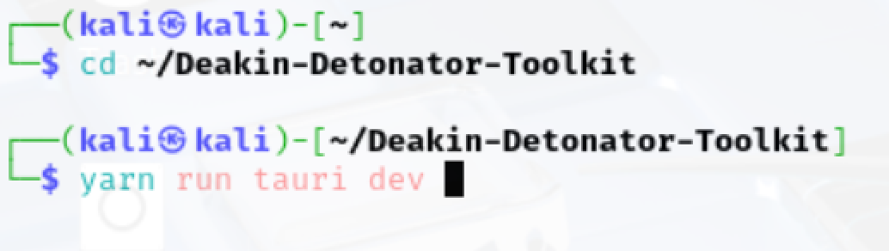
Step 2: Locate the Tool
- Click on “Tools” from the left-hand side menu or use the search bar.

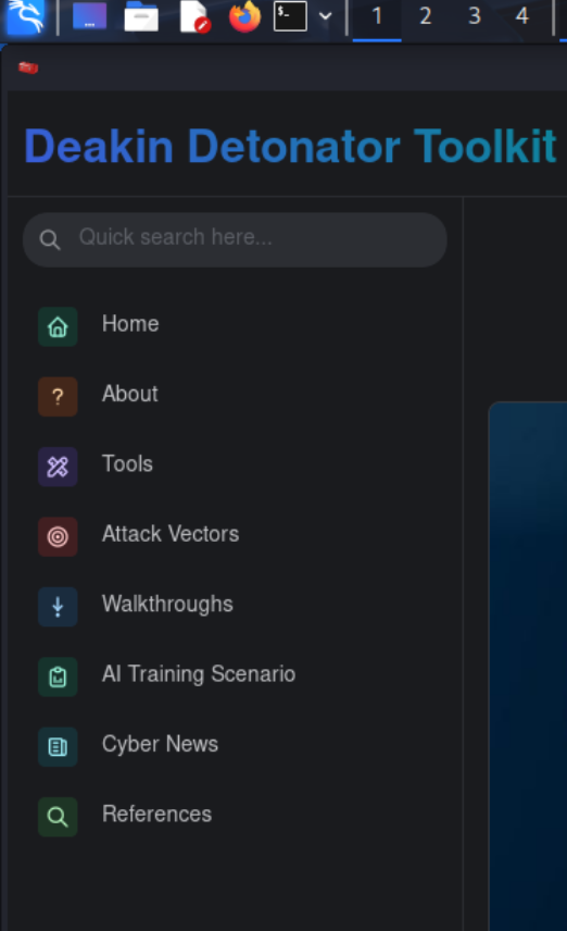

- Look for NetDiscover under the Network Scanning and Enumeration category.
- Click the blue “Go” button next to the tool name to open it.

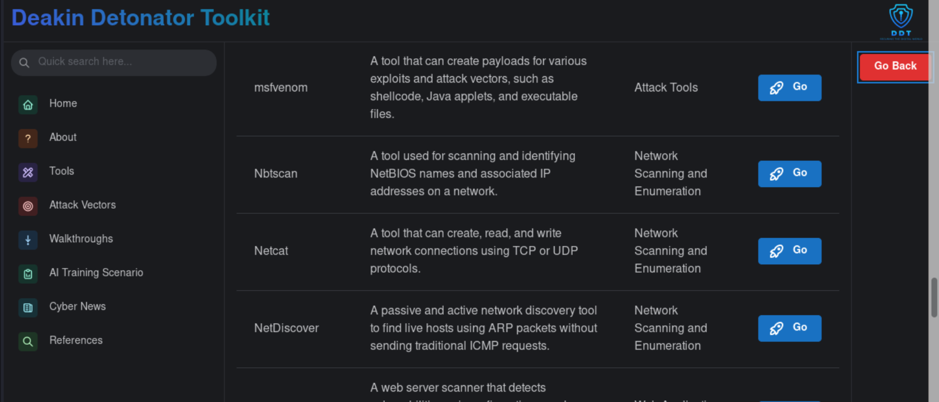

Step 3: Configure the Tool
- The tool interface contains three tabs: User Guide, Configuration, and Tutorial.
- Under the Configuration tab, fill in the following:
  - Network Interface: Example - eth0
- Click the Start Scan button to begin.

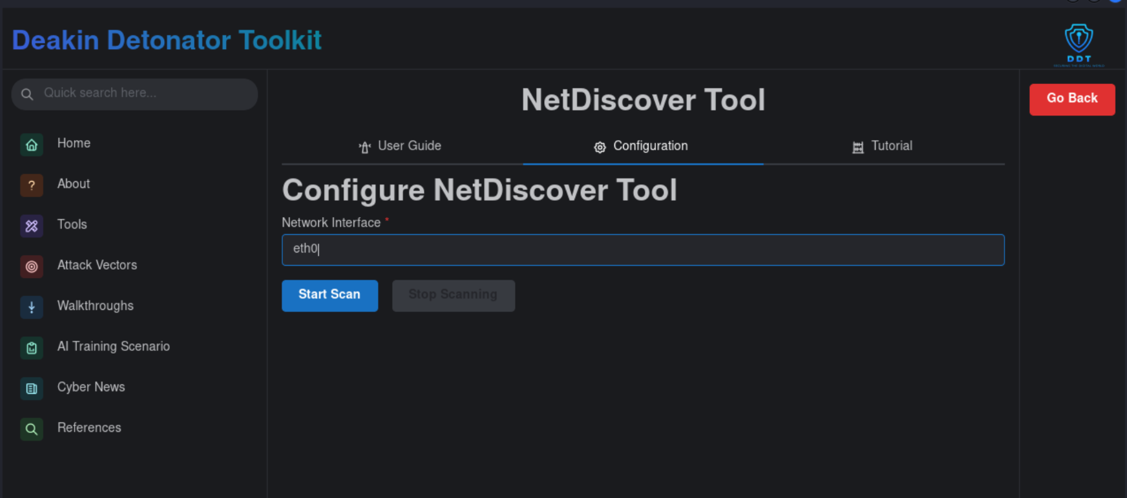

You may receive a superuser prompt like: Authentication is needed to run /usr/sbin/netdiscover -i eth0. Enter your root password (e.g., KALI) to authorize.

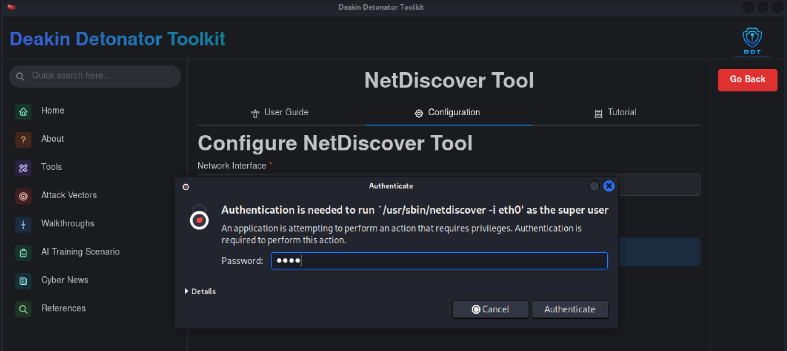

Step 4: Viewing Output & Interpretation
- As soon as the scan starts, the tool displays real-time results in the interface. The output includes:
  - IP Address: The IP address of devices detected in the local subnet.
  - MAC Address: The hardware address used to identify network interfaces on the device.
  - Packet Count: Number of ARP packets seen from each detected host.
  - MAC Vendor/Hostname: Identifies the manufacturer or hostname of the device based on the MAC address prefix.
These details help in recognizing live hosts and understanding the types of devices active on the network
- As seen in the interface, it shows real-time output of scanned IP ranges (e.g., 192.168.x.x/16) and results per subnet.

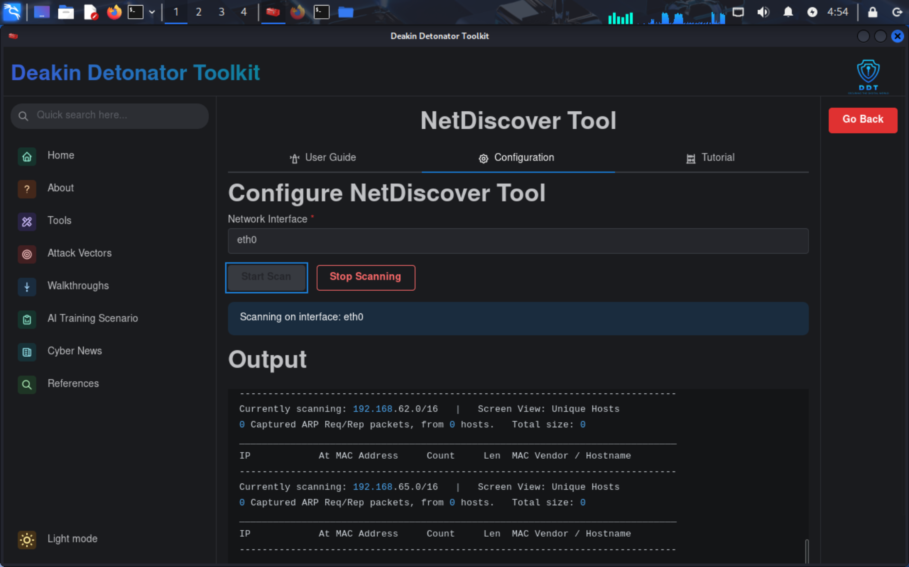

Saving, Clearing, and Resetting Output
Step 5: Saving and Clearing Output
- Once the scan completes (or is manually stopped with Stop Scanning):
  - Click Save Output To File, type a filename (e.g., output.txt), and save.
  - Click Clear Output to remove all results from the current session.

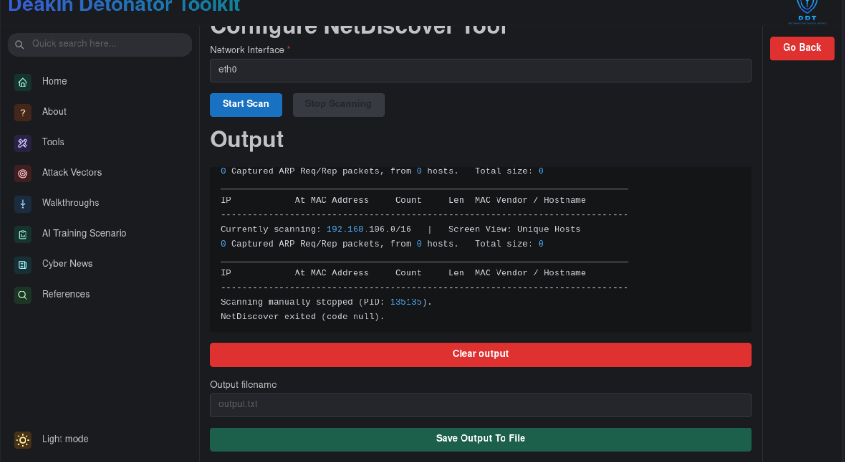

Troubleshooting & Visuals
Common Issues & Fixes:
- Interface Not Detected: Ensure you enter the correct interface (e.g., eth0, wlan0). Use ifconfig or ip a to find available interfaces.
- Permission Denied: Make sure you run the scan with superuser privileges.
- No Output: Make sure the system is connected to a network with other active hosts.

